Title of the Paper
First Author ¹⁾ , Second Author ²⁾ , Third Author ³⁾
¹⁾³⁾Affiliation information, City, Country
¹⁾author1@domain.ac.id, ³⁾author2@domain.ac.id
²⁾ Affiliation information, City, Country
²⁾author2@domain.ac.id

Abstract
Background: The abstract should begin with a concise explanation of the background, outlining the current state of knowledge or the specific problem regarding the issue being discussed to provide necessary context for the reader.
Objective: Following the background, the authors must clearly articulate the primary objective of the research, specifying exactly what the study aims to investigate, the solution proposed, or the hypothesis being tested within the scope of information technology and business innovation.
Methods: This section needs to briefly describe the methodological approach employed to achieve the research objectives, explicitly stating whether the study utilizes quantitative analysis, qualitative surveys, randomized controlled trials, experimental design, or a comprehensive literature review.
Results: Authors are required to present the key findings of the research, detailing specific data, observed outcomes, or system performance metrics without being vague; it is crucial to state exactly what was discovered during the investigation to support the conclusion.
Conclusion: Finally, the abstract must conclude with a summary of the implications of the results, discussing whether the initial research objectives were met, the significance of the findings, and suggesting potential avenues for future research or practical applications.

(The abstract must be arranged in a structured manner as shown above, consisting of a minimum of 150 words to a maximum of 300 words. Please ensure the abstract is self-contained and understandable without reference to the main text.).

Keywords: Keyword 1, Keyword 2, Keyword 3, Keyword 4, Keyword 5 (Authors must provide a list of keywords ranging from a minimum of three to a maximum of five phrases. These keywords should be carefully selected to accurately represent the core content, main contribution, or purpose of the manuscript to facilitate effective indexing and searchability.)

Article history: Received 5 February 20XX, first decision 22 March 20XX, accepted 22 May 20XX, available online 28 July 20XX

Introduction
This document is designed to serve as a comprehensive guide for authors, providing all the necessary formatting specifications required for preparing electronic versions of manuscripts submitted to the Journal of Information Technology and Business Innovation (JITBI). The standard components of the paper have been strictly specified for three primary reasons: first, to facilitate ease of use for authors when formatting their individual papers; second, to ensure automatic compliance with electronic requirements that allow for the concurrent or subsequent production of electronic products; and third, to maintain a conformity of style throughout the journal publication.
In general, a typical manuscript submitted to this journal should contain a word count ranging between 3,000 and 6,000 words, although there are no rigorous restrictions if the content justifies a different length. Please note that the margins, column widths, line spacing, and type styles are already built-in within this template; therefore, authors are strongly advised not to alter these settings. Examples of the correct type styles are provided throughout this document for your reference.
Manuscripts must be rigorously structured using the standard IMRaD format (Introduction, Method, Results, Discussion, and Conclusion) to ensure a logical flow of scientific communication. Consequently, the Introduction, Method, Results, Discussion, and Conclusion must be organized into separate, clearly defined sections. If considered necessary to support the theoretical framework, authors may add a dedicated Literature Review section immediately preceding the Method section.
Regarding language requirements, manuscripts must be submitted in grammatically correct English, specifically using standard American English, for the benefit of readers, reviewers, and editors alike. In accordance with our editorial policies, to improve the quality of journal articles, we require authors to utilize professional English editing or proofreading services if the paper is accepted for publication.
The introduction section itself must comprehensively explain the context or object of the research and articulate why this research is important. It must focus strictly in accordance with the scope of the title. Furthermore, authors are legally required to include an analysis of the existing research gap, explaining the unique differences of this study compared to similar previous studies. To demonstrate this gap effectively, authors should cite at least six recent papers that are closely related to the title of the manuscript. Finally, the specific research objectives and the intended contributions of the manuscript must be written explicitly at the end of this section.

Literature Review (Optional)
The inclusion of a dedicated Related Works or Literature Review section is generally considered optional within the manuscript structure of JITBI. This specific section should only be incorporated if the background explanation regarding previous research provided in the Introduction is deemed insufficient to fully contextualize the study.
A well-constructed literature review serves as a critical, analytical summary and synthesis of the current state of knowledge regarding the topic. It is expected to go beyond merely summarizing individual papers; rather, it should compare and relate different theories, findings, and methodologies to establish a clear theoretical framework. Furthermore, the review should maintain a particular focus or overarching theme to organize the analysis effectively, demonstrating how the current study fits into the broader academic conversation.
Regarding the length, if this section is included, it typically spans between 300 and 600 words. Authors are encouraged to use sub-headings to organize the content logically. The maximum depth for these sections is Subheading 3. Please strictly utilize the Microsoft Word template styles provided in this document (e.g., Heading 1, Heading 2, etc.) for all layout formatting to ensure consistency.
Finally, to maintain the flow of the narrative, authors are requested to avoid the use of bullet points and numbering lists within the manuscript body; please present all points in paragraph format.
  - Subheading 2
(Text for subheading 2 goes here. Use this style for major sub-sections within the chapter.).
    - Subheading 3
(Text for subheading 3 goes here. This is the maximum depth of the subheading allowed in this journal.).

Methods
The methods section, while occasionally presented under different titles depending on the specific nature of the article, serves a singular and unified purpose: to detail the methodology employed in a strictly objective manner, devoid of any interpretation or opinion at this stage. It is essential that this section communicates clearly to the reader exactly how the results were obtained. Furthermore, the research procedures must be documented chronologically and with sufficient clarity and specificity to ensure reproducibility by other researchers.
Authors are required to provide adequate references to previously established methods while explicitly identifying any modifications or differences introduced in the current study. In the process of describing the methodology, authors are strongly recommended to cite the primary sources or experts that influenced the selection of the method used. Finally, authors are expected to fully describe the metrics, protocols, and procedures that will be used to measure, test, and evaluate the research results.
  - Figure
Figures All figures included in the manuscript must be numbered consecutively using Arabic numerals (e.g., Fig. 1, Fig. 2) and accompanied by a descriptive caption. For the purpose of uniformity, all visual materials such as photographs, schemas, graphs, and diagrams should be referred to generically as "figures". Authors must ensure that line drawings are high-quality scans or true electronic outputs; low-quality scans are strictly not acceptable for publication. Furthermore, figures must be embedded directly into the text body positioned as close as possible to the first reference to them in the paper rather than being supplied as separate files.
The figure number and its corresponding caption must be typed immediately below the illustration using 8 pt font size and aligned to the left. Ensure that lettering and symbols are clearly defined either within the caption or in a legend provided as part of the figure.
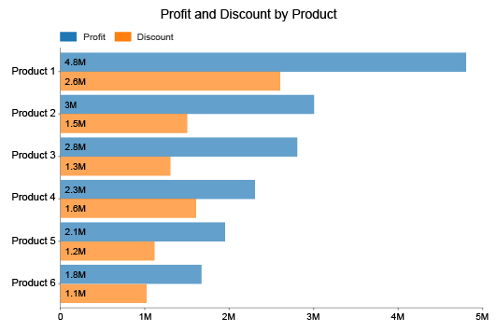
Fig. 1 Figure captions should be standalone. Descriptive enough to be understood without having to refer to the main text.
    - Picture
The preferred formats for images are PNG and JPEG. Authors are required to ensure that all figures maintain a minimum resolution of 330 PPI (pixels per inch) to facilitate high-quality reproduction on high-definition displays. To achieve this in Microsoft Word, authors should access the "Picture Format" menu, select "Compress Pictures," and adjust the "Resolution options" to meet this requirement.
    - Vector
For figures generated using vector drawing applications such as Visio, Inkscape, or Diagrams.net, it is highly preferable that they are embedded directly into the manuscript in their original vector format rather than being converted into raster pictures. This practice ensures that the resolution quality of the figure remains sharp and maintained at any zoom level.
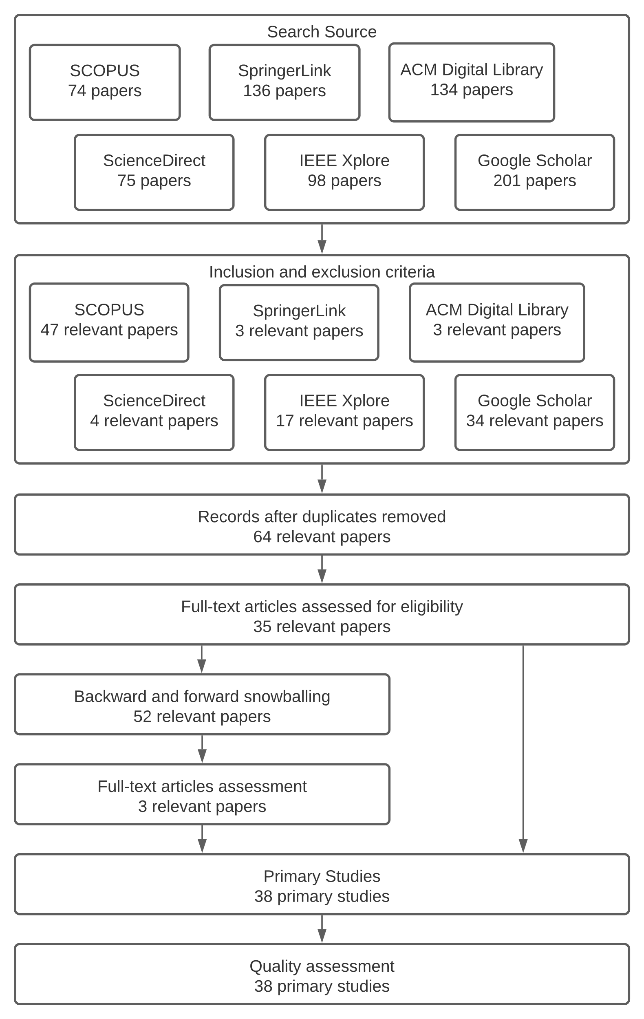
Fig. 2 Study search and selection process.
    - Graphic
Similarly, for graphics or charts created using Microsoft Office tools, authors should embed the graph directly into the Word document to preserve quality. Please ensure that all data labels are clearly visible and remove any unnecessary outline lines to enhance the visual appearance. If multiple figures share the same context, they should be arranged adjacent to one another and grouped under a single collective caption.
If figures have the same context, they should be placed next to each other and grouped into one caption. For example, see Fig. 3.
(a) | (b)
(c) | (d)
Fig. 3 Respondent profiles differentiated based on (a) Age; (b) Occupation; (c) Gender; (d) District

Table
All tables presented in the manuscript should be numbered sequentially using Arabic numerals, and each must be provided with a concise caption. Unlike figures, table headings and captions must be positioned above the table and left-justified. To maintain a clean academic style, only horizontal lines should be used within a table to distinguish column headings from the body of the table; vertical lines are strictly prohibited. Tables must be embedded directly into the text flow and not supplied separately.
TABLE 1
The significance of The Relationships in The Model
Relationships | Original Sample (O) | Sample Mean (M) | Standard Deviation (STDEV) | T Statistics (|O/STDEV|) | P Values*
Perceive Ease of Use ->Attitude | 0.286 | 0.288 | 0.058 | 4.907 | 0.000
Information Quality ->Intention to Use | 0. 175 | 0.174 | 0.072 | 2.434 | 0.015
Intention to Use ->Use | 0.657 | 0.658 | 0.039 | 17.054 | 0.000
Use ->Net Benefits | 0.463 | 0.461 | 0.061 | 7.576 | 0.000
Use ->User Satisfaction | 0.405 | 0.400 | 0.068 | 5.936 | 0.000
Performance Expectancy -> Intention to Use | 0.052 | 0.053 | 0.058 | 0.893 | 0.372
User Satisfaction ->Net Benefits | 0.428 | 0.430 | 0.059 | 7.207 | 0.000
*alpha=0.05 (this is additional legend/caption for clarity of data description, if needed)

Algorithm
When describing computational procedures, authors are encouraged to use pseudocode or structured English. This approach allows the programmer to utilize English-like sentences to clearly explain what a program or specific logic is intended to perform, making it accessible to a broader audience. An illustrative example of the expected format for pseudocode is provided in Algorithm 1 below. Authors should ensure that the logical flow is presented with proper indentation and clear variable definitions.
Algorithm 1
Person identification
function person_identification ()
get subject and object token
for each subject and object token
set token as person
end for
return person
end function
  - Equations
Mathematical equations and formulae must be typed using Microsoft Equation Editor, MathType, or a compatible tool. Equations should be numbered consecutively throughout the manuscript using Arabic numerals enclosed in parentheses, positioned on the far right-hand side of the page (e.g., (1)), particularly if they are referred to explicitly within the text. To ensure readability, equations should be visually separated from the surrounding text by a single line of space.
       
Furthermore, authors must ensure that all symbols and variables used in the equation are defined either immediately before or directly following the equation to avoid ambiguity. When citing equations in the main text, simply use the reference number, such as "(1)"; please do not use terms like "Eq. (1)" or "equation (1)" unless the citation appears at the very beginning of a sentence (e.g., "Equation (1) demonstrates that...").

Results
The Results section, along with the subsequent Discussion section, affords authors the greatest flexibility regarding organization and content presentation. In general, the pure, unbiased results should be presented first without immediate interpretation. Authors are expected to present the data or outcomes obtained after applying the techniques detailed in the methods section. It is crucial to remember that results are simply findings; they do not yet draw conclusions. In this section, authors must articulate the research results in a logical sequence that mirrors the research flow. Study results can be presented using a combination of narrative text, tables, or visual images such as graphs and diagrams.
Authors should avoid displaying raw data; instead, they are required to clearly describe the evaluation result of the study. The primary objective of this section is to provide sufficient data so that other researchers can independently draw their own conclusions and fully comprehend the basis for the final conclusions. A widely accepted format is to present a series of figures followed by a detailed textual description of each. A high-quality results section combines clear, high-resolution figures with efficient, descriptive text. These figures must directly support the assertions made in the paper or illustrate new insights. Additionally, where applicable, results should be illustrated in terms of non-dimensional variables.

Discussion
The Discussion section is the pivotal part of the manuscript where the article interprets the results to reach its major conclusions. This is the stage where the author’s opinion is introduced and the central argument is constructed. A comprehensive discussion typically includes several key features: providing an accurate assessment of the insights gained from the study , comparing these results with findings from other studies , and effectively contextualizing the results within the existing body of knowledge. Furthermore, authors must acknowledge any limitations or constraints encountered during the research (such as threats to validity) and offer specific, well-justified recommendations for fellow researchers.
Conversely, it is important to avoid common pitfalls, such as the repetition of results already presented or the introduction of new results that were not previously described in the methods or results sections. Authors should also avoid introducing relevant literature that should have been discussed earlier. Care must be taken not to overemphasize the significance of findings, especially where statistical significance was not achieved , nor to downplay findings when valuable lessons can be derived. Finally, authors should refrain from making overly ambitious or overly cautious suggestions for future research or applications.

Conclusions
In the conclusion section, the authors must explicitly articulate the manuscript's contribution based on the obtained results to definitively answer the research questions posed at the beginning of the study. This section should contain a comprehensive summary of what has been learned from the results, as well as an identification of what aspects require improvement in further studies. Furthermore, other essential features of the conclusion include detailing the practical benefits and applications of the research, acknowledging any limitations encountered, and providing specific recommendations based on the results obtained.
Author Contributions: A short paragraph specifying the individual contribution of each author must be provided to ensure transparency. Please strictly utilize the CRediT taxonomy to describe these roles (e.g., Conceptualization, Methodology, Software, Validation, Writing – Review & Editing). This statement is mandatory for all submissions. All authors must confirm that they have read and agreed to the published version of the manuscript. Example: [First Author]: Conceptualization, Methodology, Writing - Original Draft. [Second Author]: Software, Investigation, Data Curation.
Funding: Authors are required to declare any financial support received for the research. If the work was supported by a specific grant, please state the sponsor's name and the grant number. Conversely, if no funding was received, authors must explicitly state: "This research received no specific grant from any funding agency in the public, commercial, or not-for-profit sectors." This statement is mandatory
Acknowledgments: You may recognize other people who contributed to the article or data contained in the article, but at a level of effort that does not justify their inclusion as authors. – this statement is optional; you may delete this part.
Conflicts of Interest: Authors must declare any personal or financial relationships that could be perceived as potential competing interests. If specific interests exist, they must be detailed (e.g., "First Author reports financial support was provided by..."). If there are no conflicts, authors must state: "The authors declare no conflict of interest." This statement is mandatory.
Data Availability: A statement explaining the accessibility of the data and/or source code that underlies the results presented in the paper must be included. If the data is stored in a public repository, please provide valid hyperlinks whenever possible. In cases where data cannot be openly shared (e.g., for privacy protection), it is essential to explain this restriction clearly. This statement is mandatory
Informed Consent: There were no human subjects. / Informed Consent was obtained, and a detailed explanation was presented in the Methods section. / The consent cannot be obtained; Providing an explanation is necessary, and the text should include a description of an alternative process that has received ethical approval and should be followed. – this statement is mandatory.

References
We suggest there should be at least 20 references within the manuscript. Make sure you use Mendeley feature in Microsoft Word for handling citation in manuscript. Please use IEEE Journal standard for Reference style in Mendeley. References may not include all information; please obtain and include relevant information. Title of paper with only first word capitalized. Do not combine references. There must be only one reference with each number. Please include DOI information if applicable.
The template will number citations consecutively within brackets [1]. The sentence punctuation follows the bracket [2]. Refer simply to the reference number, as in [3]—do not use “Ref. [3]” or “reference [3]” except at the beginning of a sentence: “Reference [3] was the first ...”.

- G. Eason, B. Noble, and I.N. Sneddon, “On certain integrals of Lipschitz-Hankel type involving products of Bessel functions,” Phil. Trans. Roy. Soc. London, vol. A247, pp. 529-551, April 1955. (references)
- J. Clerk Maxwell, A Treatise on Electricity and Magnetism, 3rd ed., vol. 2. Oxford: Clarendon, 1892, pp.68-73.
- I.S. Jacobs and C.P. Bean, “Fine particles, thin films and exchange anisotropy,” in Magnetism, vol. III, G.T. Rado and H. Suhl, Eds. New York: Academic, 1963, pp. 271-350.
- K. Elissa, “Title of paper if known,” unpublished.
- R. Nicole, “Title of paper with only first word capitalized,” J. Name Stand. Abbrev., in press.
- Y. Yorozu, M. Hirano, K. Oka, and Y. Tagawa, “Electron spectroscopy studies on magneto-optical media and plastic substrate interface,” IEEE Transl. J. Magn. Japan, vol. 2, pp. 740-741, August 1987 [Digests 9th Annual Conf. Magnetics Japan, p. 301, 1982].

Corresponding author

